Walk 9 Bodenham
Last walked in April 2019

Description A 7 km (4.3 mile) easy walk with no hills, you walk across farm land and fields.
Start Parking area in Bodenham. Explorer Map 202 Grid 530509.
Directions from Whitecross roundabout (Turn milometer to zero). Take the A4110 Canon Pyon (Three Elms road) for 1 mile and TR at the traffic lights onto the A4103 Worcester (Roman road). TL at the second roundabout sign posted for Bodenham (3.2 miles). At 9.4 miles, just beyond Bodenham and before ‘England’s Gate Inn’, TL, sign posted to Bodenham Church. At 10.3 miles you TL by the memorial cross and park on the R hand side just before getting to the church (total 10.4 miles).

1. St Michael’s Church. Bodenham, St Michael’s Church. The parish church of St Michael and All Angels at Bodenham is set in a beautiful location beside the peaceful River Lugg. The church is primarily 14th century, in the Decorated Gothic style and consists of a chancel, a 3-bay nave with clerestory, south and north aisles, and a solid west tower on a square plan topped by a truncated lantern spire. Within the church are several intriguing historical monuments and a 13th century carved stone font. With your back to the car parking area TR, following the sign to the church the road bends to the R and then to the L, into the churchyard. The other side of the church you go thru the gate in the far R hand corner of the churchyard, and cross two foot bridges, the second one spans the River Lugg. TR, follow the sign to “The Vern”. Stay close to the riverbank until you reach a footbridge with a stile at each end. Negotiate this and bear slightly R to cross over F1, heading for the far corner, to cross another footbridge with a stile at each end. TR, and after a few paces bear L to climb a small bank to cross over a double stile. TL, and continue up the bank and into a F2. Bear diagonally R across this field, head for the L hand side of a small wood, and on reaching it you continue thru a gap and along an enclosed green lane. After a short distance you go thru a small metal gate to emerge onto a road, with the Vern being on your R.

2. Roadway. TL and follow this road for about 130m, just before two poplar trees either side of the road you TL and cross over three planks and a stile into the same field as before {F2}. Walk straight ahead, keeping close to the edge of the garden on your R. At the end of the garden TR and follow the field boundary, that soon bends L. Continue on, and when you reach the far R hand corner of the large field, go thru a wide gap on your R and into F3. Continue in the same direction as you make your way to the woods (Ashgrove Wood), keep to the fence on your L. At the end of the field (after about 80m) TL, go over a stile/metal gate into F4, TR and continue along the R field boundary. After about 130m, (near the end of the field), you TR and cross over a footbridge with a stile at each end, into F5. Head half L across the field to reach the bridge behind the church, back to the junction of paths.

3. River Bridge. Don’t go over the bridge but head off to the R, and follow the sign for Bodenham Moor (1 mile). Follow the river (L), and at the end of the field you cross a stile into F6. At the end of this field you cross a stile into F7. You leave the river and head diagonally R across this field, to cross a stile that’s in a fence corner, underneath a big oak tree, and go into F8. Continue straight across this arable field, passing underneath power lines to cross a stile onto a narrow road. Cross the road, climb over a stile/metal gate into F9, continue in the same direction across this field, to meet a tree line/small stream on the L. Continue along the L field edge to cross over a stile into F10. Continue along the L field edge for about 50m then TL, cross over a concrete footbridge and turn immediately R thru a small metal gate into F11. Go diagonally L across this field, heading towards two tall popular trees and the back gardens of some houses. On reaching the two popular trees you go thru a gate gap onto the road called Orchard Close. TR and then follow the close to its T-junction where you TL onto the main road. Continue on thru the village, ignoring any side turnings, to reach the England’s Gate Inn.

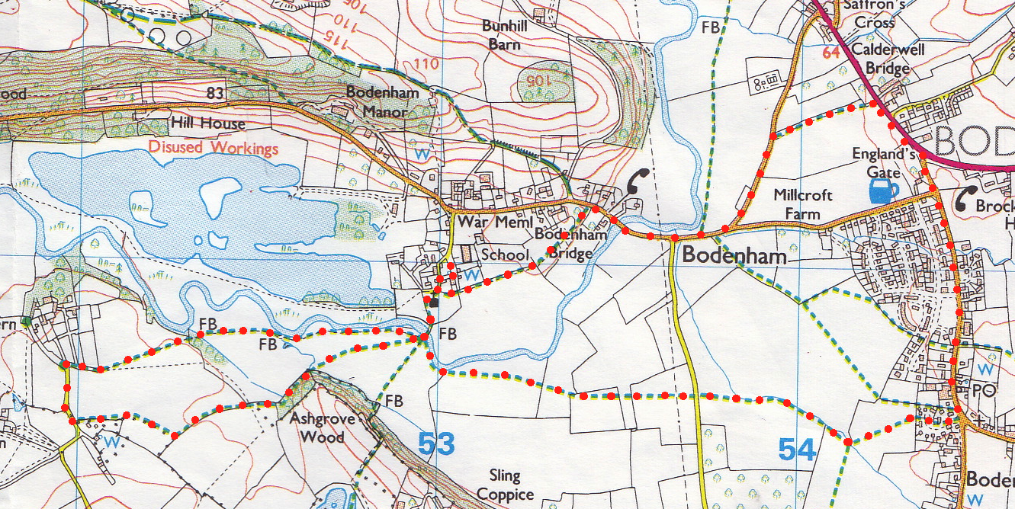
4. England’s Gate Inn. Pass the pub on your L to reach the T-Junction where you TL onto the main A49/A417 road. Walk along the main road, taking great care as the traffic is often heavy and fast. Take the first yellow waymark sign on the L (opposite Calderwell Farm, the last in a line of houses on the other side of the road) and go thru a small wooden gate into F12. Keep to the R field edge and go round the field boundary. TR when you reach a small gap in the hedge that’s underneath a public footpath sign, onto a narrow road. TL and continue along to the end of the road and TR at the T-Junction. Carry on along this road, ignoring any turnings, crossing over Bodenham Bridge, (the river Lugg flows underneath). Carry on along this road and take the first Public Footpath sign on the L, passing thru a kissing gate. Follow the footpath signs, keeping the hedge on your L, and pass thru two more kissing gates to reach F13. Cross this small field and go thru a gap in the hedge/tree line, that’s underneath the R hand popular tree, into F14. Continue in the same direction across this field and along the R field edge, to go thru a metal kissing gate into the churchyard. Follow the path thru to the lichgate on your R, to leave the churchyard and walk back to your car.
1
2
3
4
1

